***System analysis project***

1. Case: **Event management system**

**Background**: The event management system is an automated system for event management. It is capable of managing multiple events happening if different locations. The system enables even the remote client to make online registrations. It is powerful, user friendly and flexible and it offers great degree of customization with ease of management. The context of event flows includes multiple states and participation from different people such as event registration, pending registration, cancelled event, approved registration, attendees, and event managers. The objective of this application is to develop system that effectively manages all the data related to the various events that take place in an organization. The purpose is to maintain a centralized database of all event related information. The goal to support various functions and processes necessary to manage the data efficiently.

1. **Domain and scope of study:**

**Domain of Study:**

* **Event Planning and Coordination:** This includes the process of conceptualizing, planning, and coordinating events of various types and scales.
* **Event Logistics:** Managing logistics such as venue selection, catering, transportation, and accommodation for participants.
* **Event Marketing and Promotion:** Strategies for promoting events, managing registrations, and ensuring attendance.
* **Budgeting and Financial Management:** Handling budgeting, cost estimation, financial planning, and accounting related to events.
* **Risk Management:** Identifying potential risks associated with events and developing strategies to mitigate them.
* **Technology and Tools:** Utilizing event management software, mobile apps, and other technological tools to streamline processes.
* **Legal and Compliance:** Ensuring compliance with regulations related to events, such as permits and safety standards.

• **Scope of Study:**

* **Types of Events:** Differentiating between corporate events, conferences, seminars, weddings, concerts, festivals, etc., each with unique requirements.
* **Stakeholder Management:** Engaging with clients, vendors, sponsors, and attendees to meet their expectations and ensure smooth execution.
* **Project Management:** Applying project management principles to plan, execute, monitor, and evaluate events effectively.
* **Sustainability:** Incorporating sustainable practices into event planning and management.
* **Emerging Trends:** Keeping up with industry trends like virtual events, hybrid events, and experiential marketing.
* **Evaluation and Feedback:** Gathering feedback from participants and stakeholders to improve future events.

• **Technological Integration:**

* **Event Management Software:** Exploring features such as registration management, attendee tracking, scheduling, and communication tools.
* **Mobile Apps:** Developing apps for event information dissemination, networking, and engagement.
* **Integration with Social Media:** Leveraging social media platforms for event promotion, live updates, and attendee interaction.

• **Special Considerations:**

* **Cultural Sensitivity:** Recognizing cultural differences in event planning and execution.
* **Crisis Management:** Developing contingency plans for emergencies and unforeseen circumstances.
* **Ethical Considerations:** Ensuring ethical practices in dealing with sponsors, attendees, and stakeholders.

1. **Functional Requirements:**

• **User Registration and Management:**

* The system should allow users (event organizers, participants, administrators) to register and manage their profiles.
* It should support different user roles with varying levels of access and permissions (organizer, attendee, speaker, and administrator).

• **Event Creation and Management:**

* Organizers should be able to create new events, specifying details such as event name, date, time, location, description, and type.
* The system should support recurring events and allow organizers to manage multiple events simultaneously.

• **Registration and Ticketing:**

* Attendees should be able to register for events online through the system.
* The system should handle ticketing, including issuing tickets, managing ticket types and handling payments securely.

• **Attendee Management:**

* Organizers should be able to manage attendee information, including registrations, cancellations, and attendee communication.
* The system should provide tools for attendee check-in and badge printing at the event.

• **Schedule and Agenda Management:**

* The system should allow organizers to create event schedules, including sessions, workshops, and keynote speeches.
* Attendees should be able to view and personalize their schedules through the system.

**Accessibility and Security:**

* The system should be accessible to users with disabilities and comply with accessibility standards.
* It should implement robust security measures to protect user data, transactions, and communications.

1. **Use case diagram:**

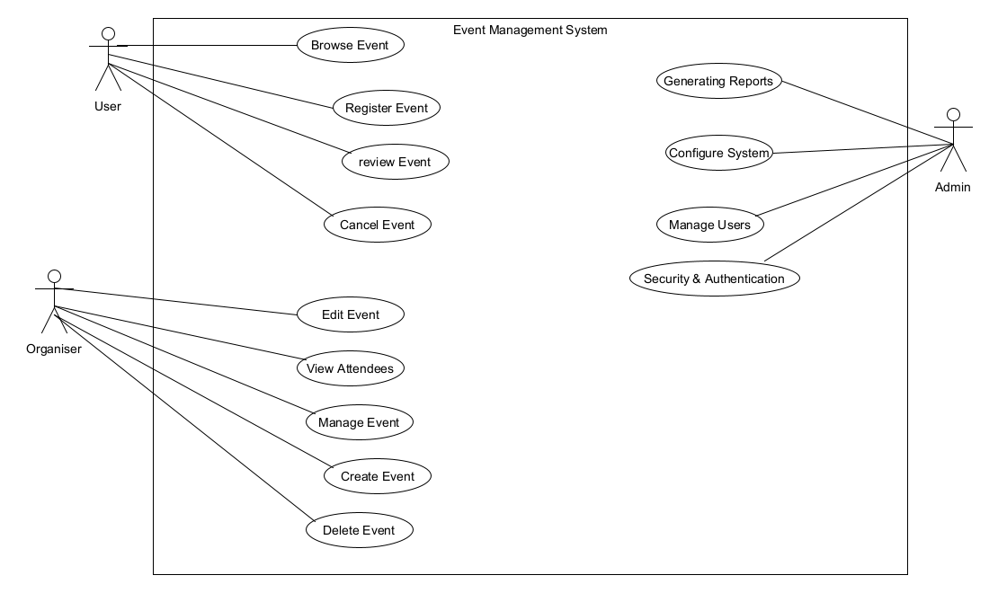

1. Class Diagram:

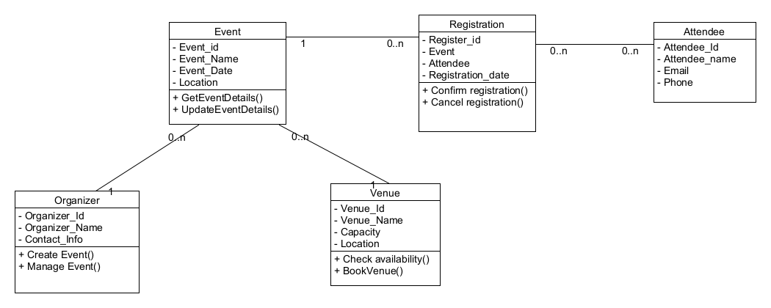

1. **Activity Diagram:**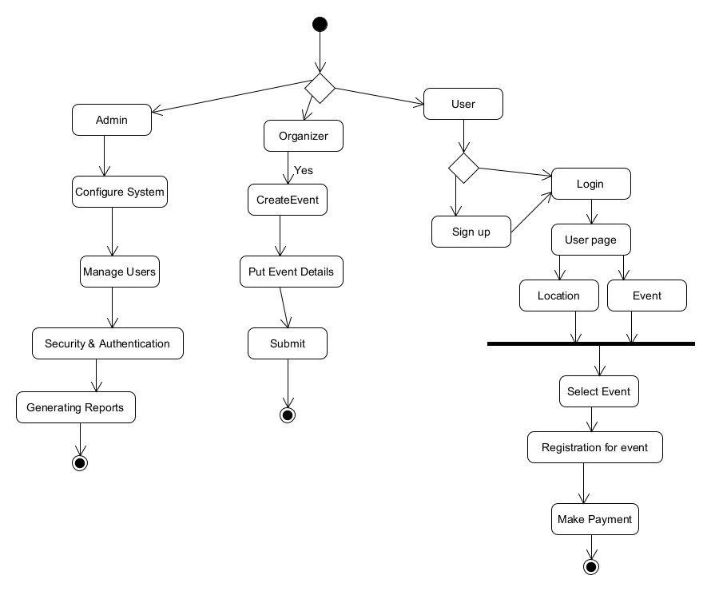
   1. **Database diagram:**

